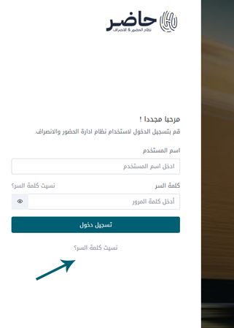
Password recovery method
In case you forget the password of the Hader system - we enter the following link: https://hadir.sar.com.sa

And then choose the button "Forgot password?" as shown in the picture

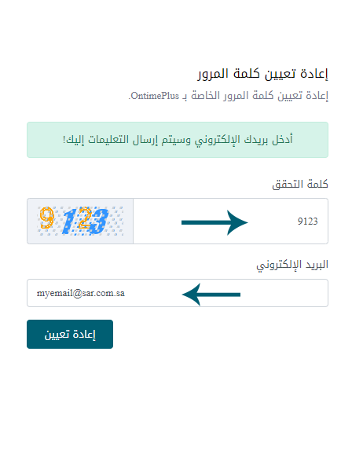
Then we enter the verification password and email of the employee
As shown in the picture
Then choose the "Reset" button

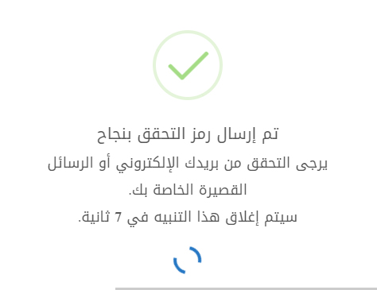

The system will send a verification word to the employee's e-mail

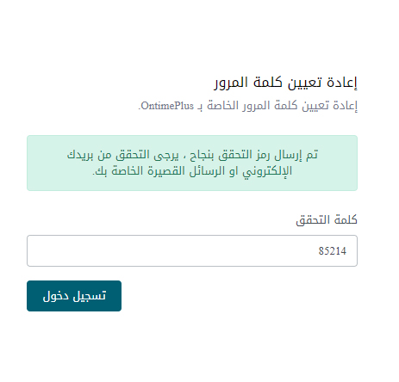

We enter the captcha sent to the email
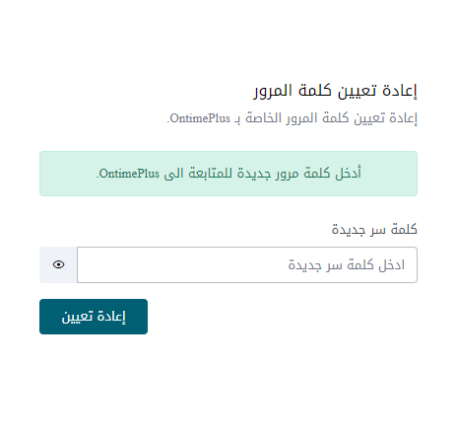
Then choose the "Login" button

Then we enter the new password
Then choose the "Reset" button

