

PASSENGER BUSINESS UNIT

STAFF
B
RIEFING – ALL STAFF

Train Fuelling Instructions – Riyadh RRS (EWR)
Date: | 24th March 2025 | Location: | Riyadh RRS

ALL STAFF - Briefing
Following an incident in which a train, being moved by a loco pusher on the wheel lathe road, ran over and severed a fuelling hose (see pictures 1 & 2)
the following instructions will apply with immediate effect.

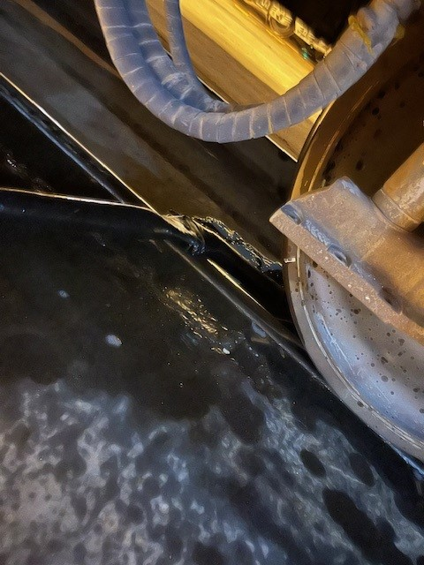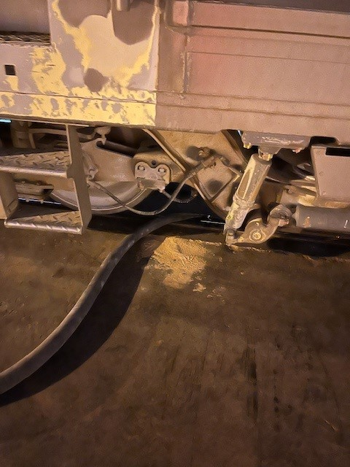
Pic 1 Pic 2

Under normal operations fuelling MUST ONLY take place on Roads 1, 2 and 3 at RRS. This applies to the current (temporary) fuelling point and will also apply when the new permanent fuelling point is introduced.

Fuelling will normally take place once train washing is completed and is designed to prevent the fuel pipe being extended over adjacent roads.

It is the intention that trains should not be stabled without having already been fuelled, this will remove the need to fuel after the train has been left in the depot, which would increase the risk of fuelling activity taking place on roads 6, 7 or 8.

If for any reason there is a need to fuel on roads 6, 7 or 8 then the following instructions MUST be applied.

- The fuel pump operator must communicate with the team leader before starting any fuelling activity, to ensure no train movements are undertaken on the lathe line, this communication should be repeated to confirm when fuelling is complete.

- If available the Terminal Operator must support the initial movement to ensure that no fuel lines, or other obstructions or people could be harmed by the movement being undertaken.

- If the Terminal Operator is NOT available then RSM teams must ensure there is someone stationed at the eastern end of the train on the lathe line, to ensure that no fuel lines, or other obstructions or people could be harmed by the movement.

- RSM teams are to ensure all communications between the Loco Pusher operator and the person at the other end of the moving train, are made using two radios, to ensure controlled, consistent communications are undertaken during any movement.

If you have any issues please contact one of the PBU Train Operations or PBU RSM management teams to discuss further.

Created by: Simon Moran – Section Head, Train Operations, EWR.

PASSENGER BUSINESS UNIT

STAFF
B
RIEFING

